
Sol Global Solar Sol Global Solar

100% American Made Technical Sheet 260W Mono PV Module
Material and Assembly

Greenway GS260WM

Warranty 27 years

Electrical Characteristics

Maximum Power (Pmax) 260 Watt
Power Tolerance +3 %
Maximum Power Voltage (Vmp) 47.65 Volt
Maximum Power Current (lmp) 5.46 Ampere
Open circuit Voltage (Voc) 59.20 Volt
Short circuit Current (lsc) 5.80 Ampere
Maximum System Voltage 1000 Volt DC
Module Efficiency (ηm) 16.04 %
Temp. coefficient Voc -0.35±0.02 %/℃
Temp. Coefficient Isc +0.04±0.0015 %/℃
Temp. Coefficient Power -0.5±0.05 %/℃
Nominal operating cell temperature (NOCT) 47°C±2°C ℃

Cells
Brand Name of Solar Cells Greenway
Cell Type Mono Crystalline Cell
Cell Size 5”x 5”
Cell Shape Quasi Square
Number Cells 104 in series
Encapsulated Solar Cells Efficiency (ηc) 17.5 %
Standard Test Conditions UL 1703
Irradiation 1000W/m2 Tc 25°C

Mechanical Characteristics

Dimensions
Length 68 1/4”
Width 42 3/8”
Depth 1.5”

Installation Dimensions
Length 68 3/4”
Width 42 7/8”
Weight 45 LB
Frame Aluminum 45 degree Corners

Front side Glass Tempered 91% Transmission
Front glass thickness 1/8”
Encapsulate EVA
Back side FPE
Junction Box Greenway

Absolute Maximum Ratings
Operating Temperature -40℃～+90℃ ℃
Storage Temperature -40℃～+90℃ ℃
Dielectric Isolation Voltage 1000 VDC max 1000V
Maximum Wind Resistance 60m/s N/m2 or max Km/h
Maximum Load Capacity 200 Kg/m2

Maximum Hail diameter @ 80Km/h 25mm @ 80Km/h
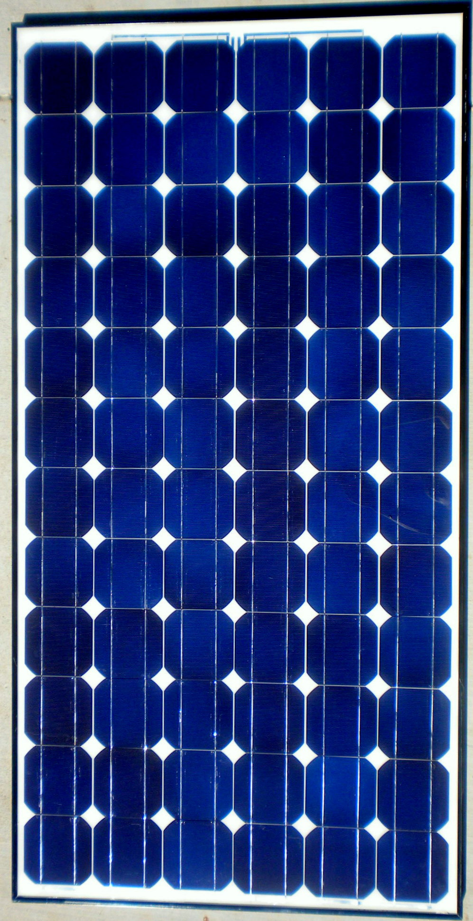

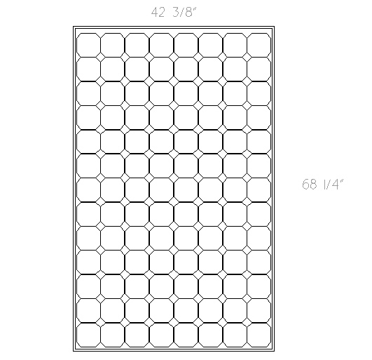

Greenway Solar Power
530-903-4804
CEC, Ul 1703, IEC, pending Oct 2010

