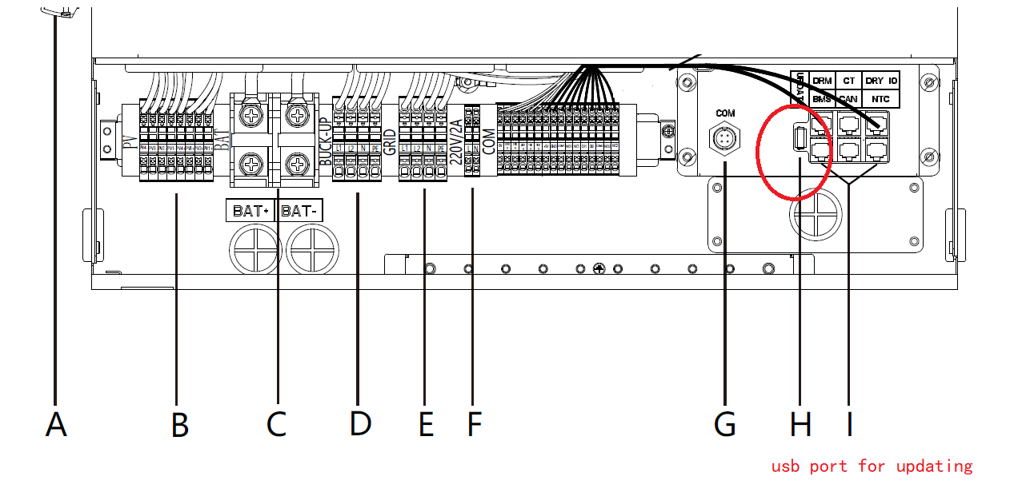

- Use the USB-C wire to connect to the pc and inverter ，power on inverter using grid or pv
- Setup the tool software,open it

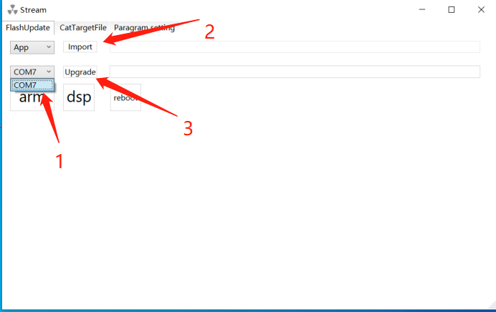
- choose the correct COM port
- choose file *.out:
- start the button “upgrade”
- Update both Firmwares on the inverter.

