# Manual Supplement

# 11. Generator Use Operation Guide

## 11.1 Generator Use Diagram

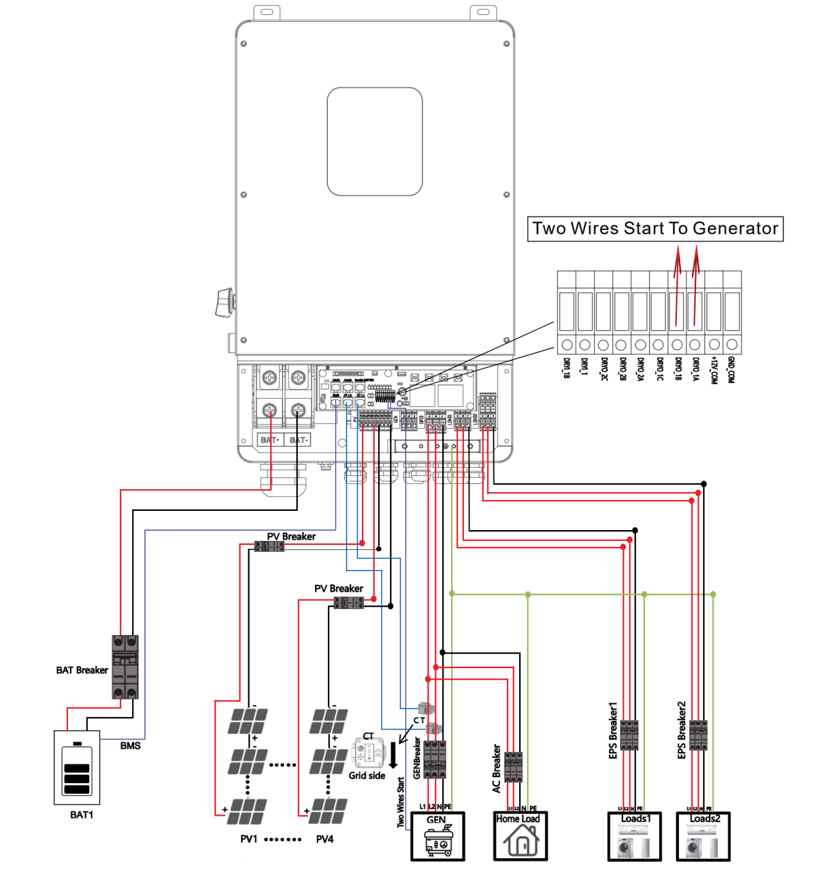1）The Generator is connected to the grid port of the inverter. The connecting cable shall be covered with CT. It is used in some off network situations. The system diagram is as follows.

1. The Generator is normally connected to the Generator port. The connecting cable between the Generator and the inverter does not need to be covered with CT. The connection line of the power grid port should be connected with CT. The system diagram is as follows.

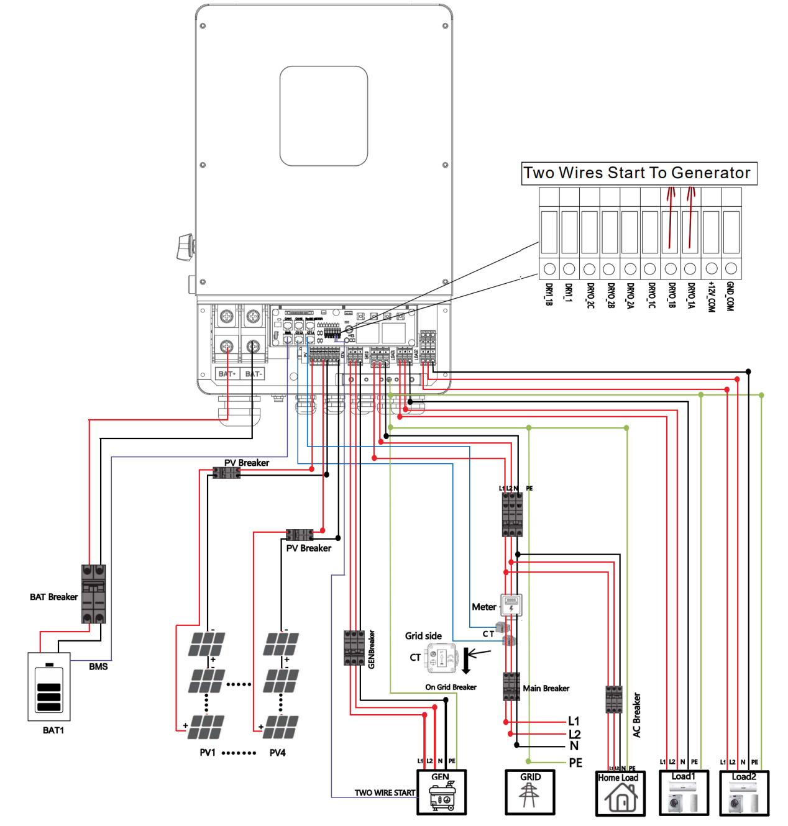

## 11.2 Generator Operation Notes

**1)** The two wire start signal **DRYO_1A** and **DRYO_1B** of the Generator is used to automatically control the start and stop of the Generator.

**2)**Make sure the inverter units software version support Generator function. **USER**->**INQUIRE**->**FIRMWARE**

FIRMWARE

ARM: V1.XX.XX DSP: V1.XX.XX V1.XX.XX DSP: V1.XX.XX

1. When the generator is used in inverter parallel situation, the two wires start signal is only needed to be connected to the master unit. The wiring and the setting of the Generator should be exactly same.

**4)**Please check the diagram above .

## 11.3 Generator Setting

The Generator setting page can be visited in the following steps in the screen:

**USER**->**1. SETUP**->**PASSORD CHECK**->**16.Generator**

**11.3.1 Setting**

|  |  |
| --- | --- |
| Interface | Description |
| Generator. 1.START SOC. 2.STOP SOC 3.ChgCurrToBAT 4.MAX RUN TIME 5.COOLDOWN 6.CONTRL  7.POWER | This interface shows Generator setting.   1. When the SOC of battery is lower than the setpoint，the Generator drycontact is enabled and Generator Manual operation is disabled, the connected Generator will be started. 2. When the SOC of battery is higher than the setpoint，the Generator drycontact is enabled and Generator Manual operation is disabled, the connected Generator will be stopped. 3. It indicates the maximum current that the inverter charges the battery from Generator. 4. It indicates the longest time Generator can run in one day, when time is up, the Generator will be turned off. The value 240 means 24hours in which state the Generator will not be shut down all the time. The unit is 0.1 hour. 5. It indicates the waiting time of the Generator to restart after it has reached the running time.The unit is 0.1 hour. 6. Refer to 11.3.2 **CONTRL.** 7. Rated power of Generator. |

**11.3.2 CONTRL**

|  |  |
| --- | --- |
| Interface | Description |
| GEN CONTROL 1.Generator En 2.Charge En 3.DryContact 4.Manual En 5.ManualCmd En 6.Connect Grid | This interface shows Generator CONTRL.   1. Enable control of the Generator function. 2. Generator Charge Enable control 3. If the user wants the Generator to be automatically controlled to start and stop through the dry contact,Enable it. 4. If the user wants the Generator to be controlled manually,Enable it. 5. The on/off command in manual control mode , 6. Connect the diesel Generator to the grid input port. |