Hybird Inverter Firmware Upgrade Guide

1.Preparation before Upgrading

a) A computer

b) A type-C cable

c) Software package

d)Firmware package

2.Upgrade Process:

2.1 Install software: click “setup” Please follow steps as below.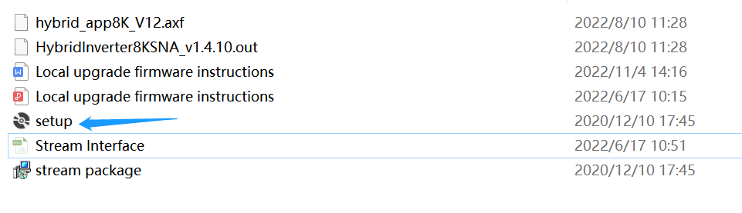

2.2 To click next, or下一步.

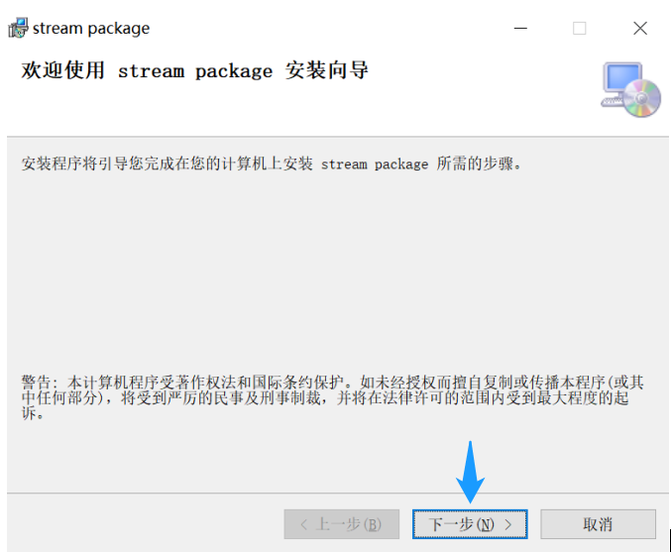

2.3 Click next or 下一步again.

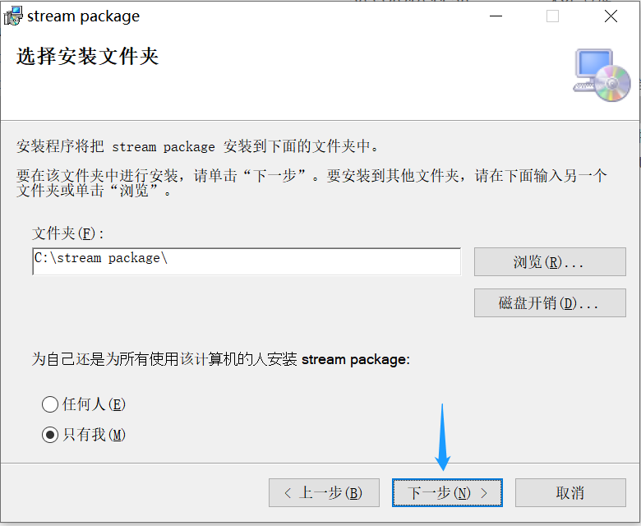

2.4 Click close or“关闭”

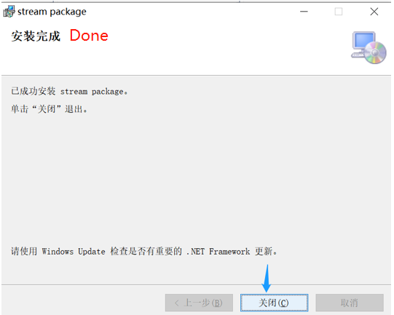

2.5 Open the software “ Stream”



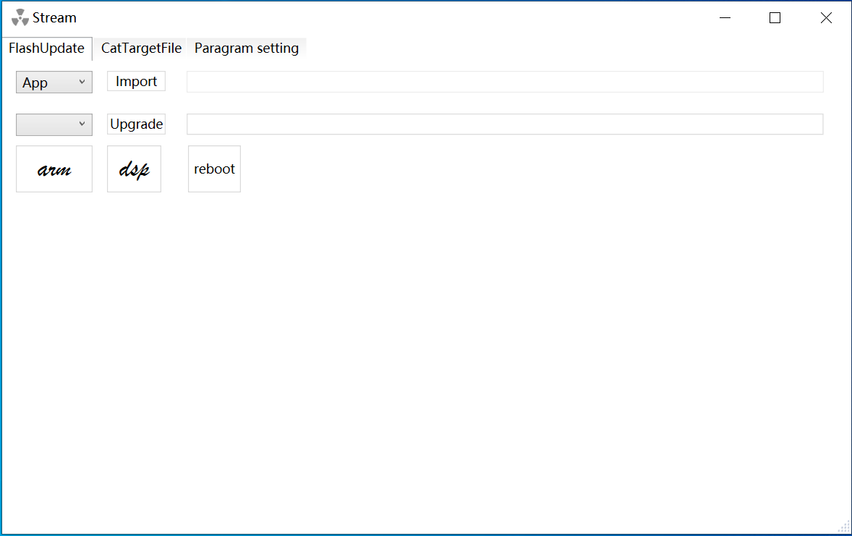

1. Connect Type-c cable：

Note: Make sure the inverter and battery are switched-on before the upgrade.

Connect the inverter and laptop.

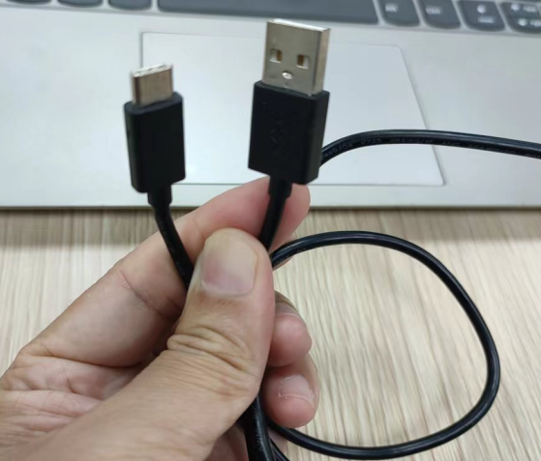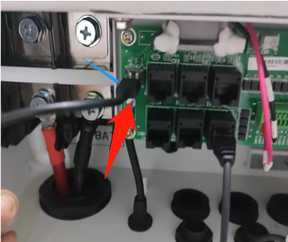

4. Start to upgrade firmware:

Note: Please make sure the inverter is switched on

4.1 Select " APP ” and **"** COM**”**

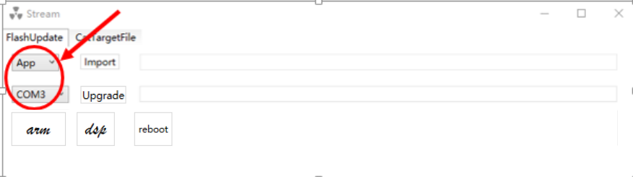

4.2 Import the file ends with.axf

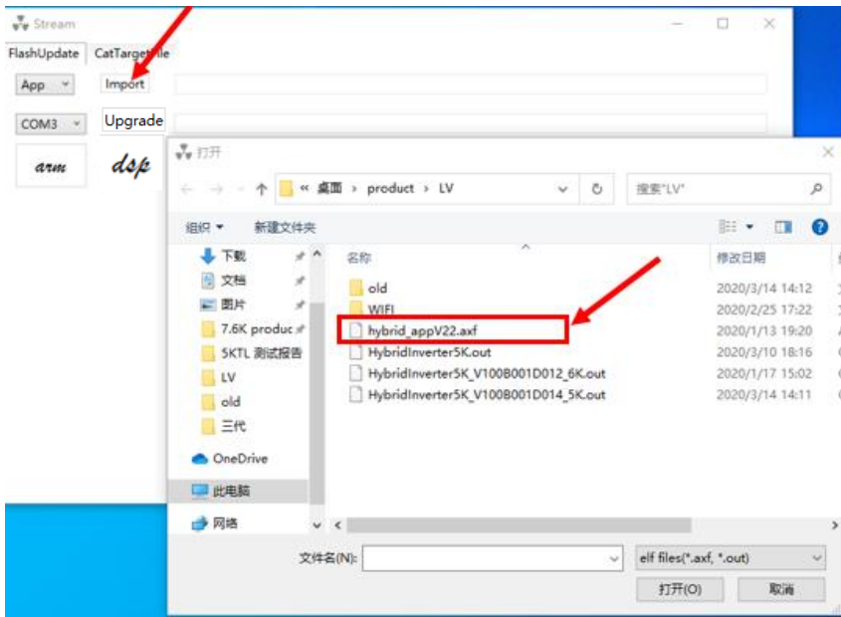

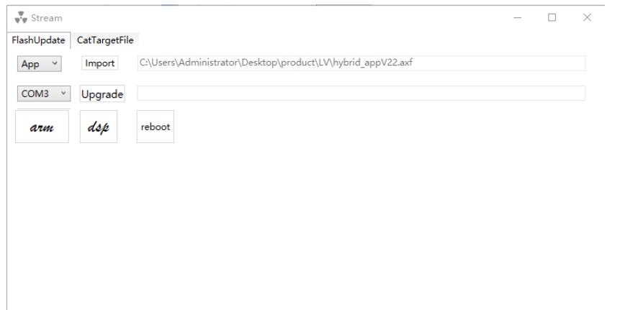

4.3 Click”Upgrade” to start the firmware upgrading，

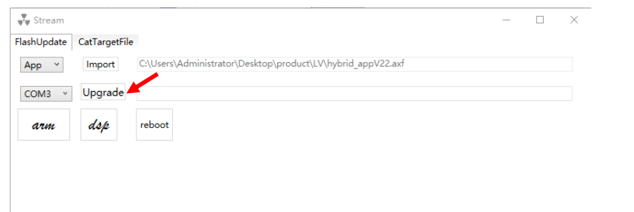

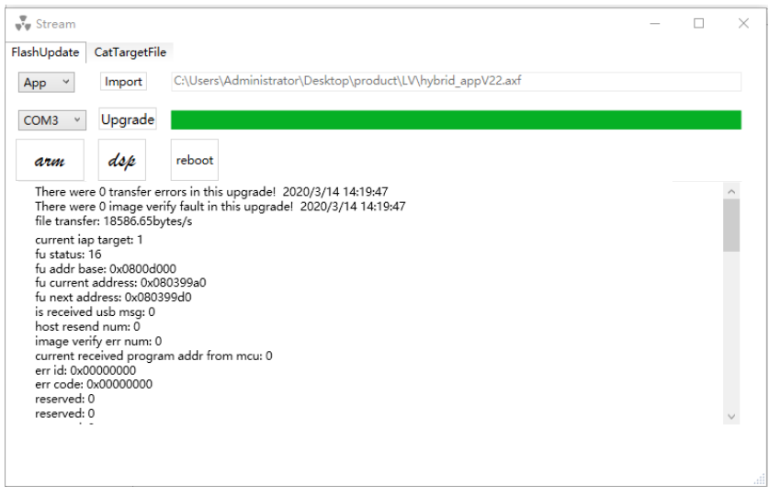

* 1. After the above file is completely upgraded, import the corresponding file ends with ".out" again.

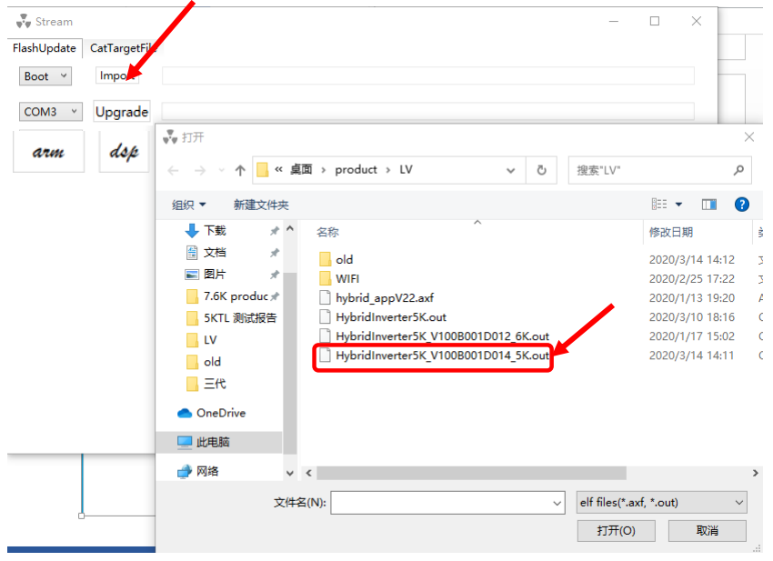

4.5 Click”Upgrade” to start the firmware upgrading，

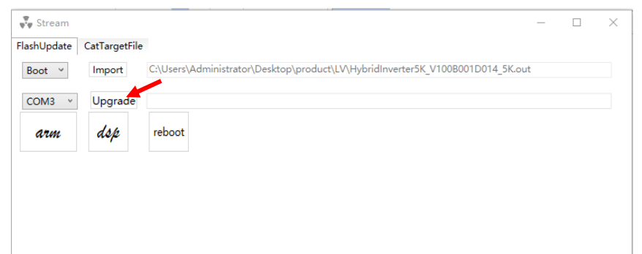

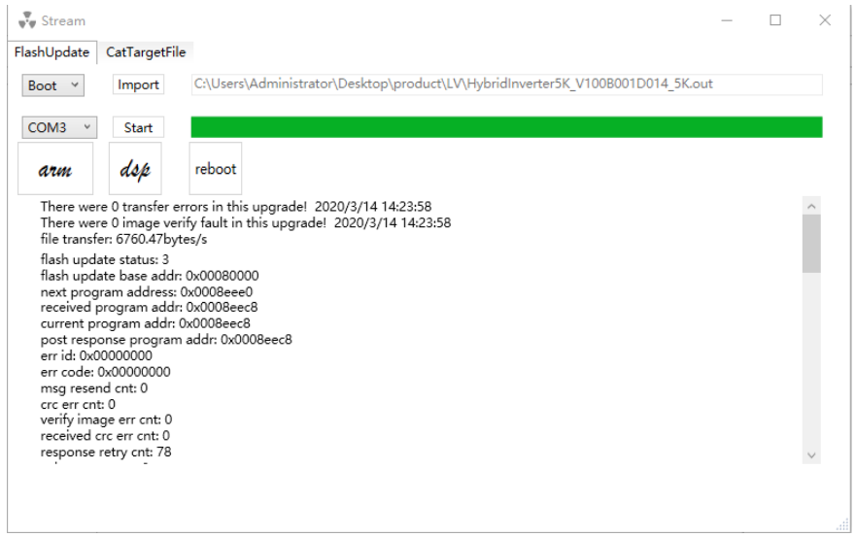

Wait till the upgrade is done. Wait for about 3-5 minutes, remove the cable and restart the inverter.

Upgrade completed!