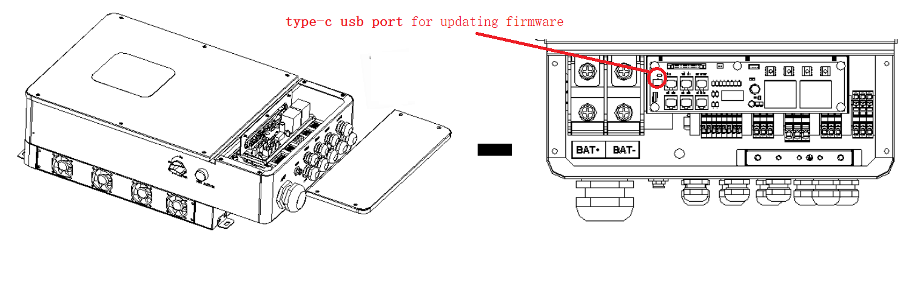
- Use the usb wire to connect to the pc and inverter ，power on inverter using grid or pv
- Setup the tool software,open it

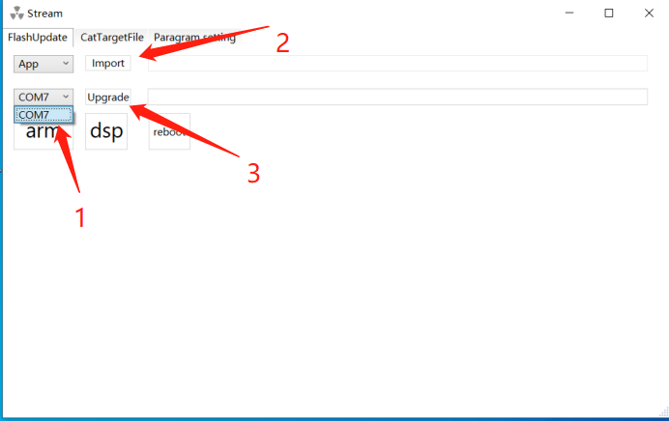
- choose the correct COM port
- choose file : .out file (For updating DSP MCU) and .axf file(For updating ARM MCU) respectively，make sure the file path without containing any space character!
- start the button “upgrade”

